

sql assignment

Shiv Patel



November 9, 2024

Just it

30-33 Minories London EC1

Contents

Task1 – MySQL Part 1: 2

Task2 - MySQL Part 2: 5

Tasks 9

Task 3 – Interview Part 1: 16

Task 4 – Interview questions Part 2: 16

# 

# Task1 – MySQL Part 1:

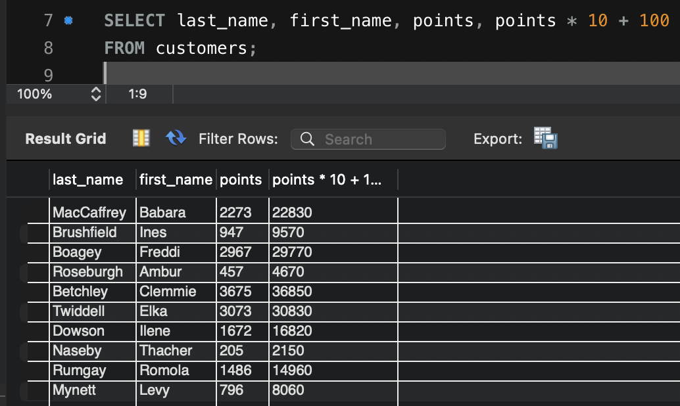Read from PPT for this task first.

Task 1 (part 1)- changing points to read *10 +100

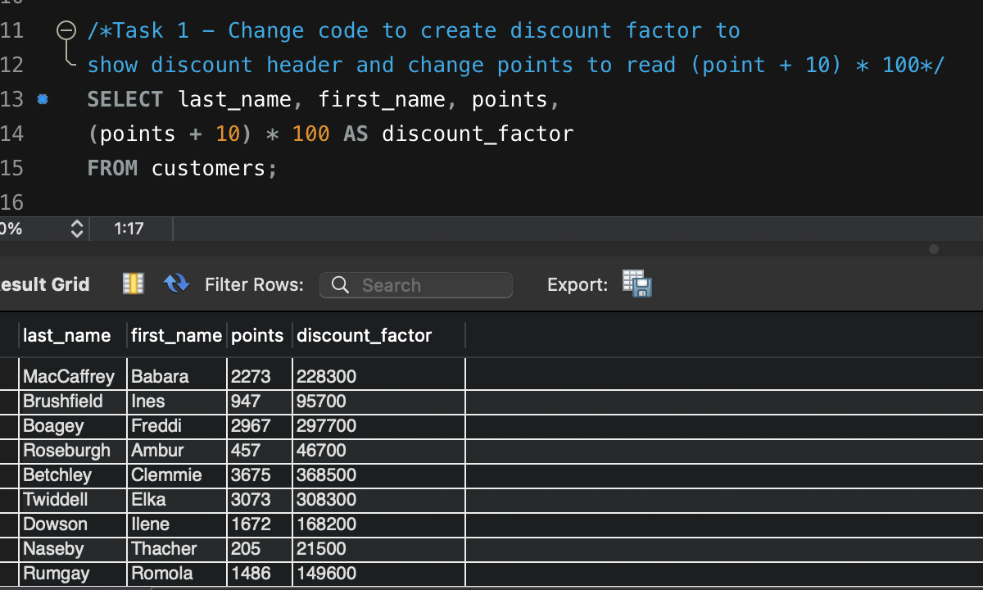

Task 1 (part 2) - Creating discount factor with (points +10) * 100

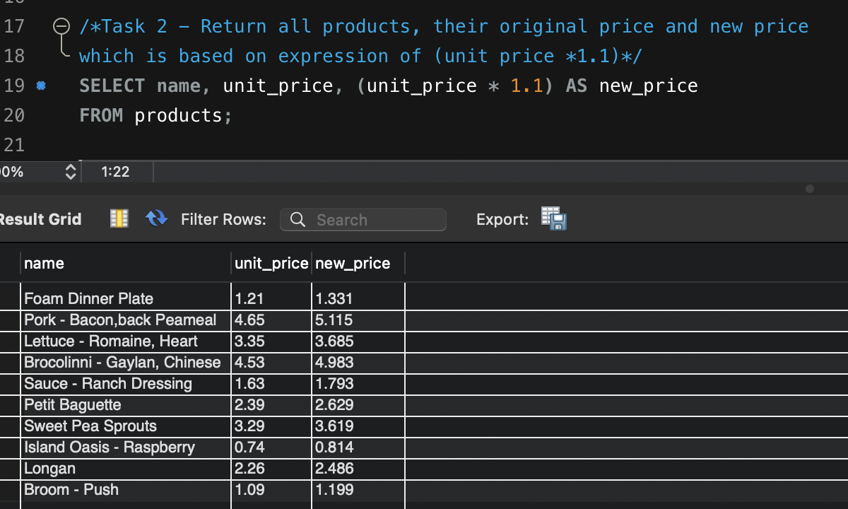

Task 2 - Returning all products whilst displaying new column for new price where unit price has increased by 10%

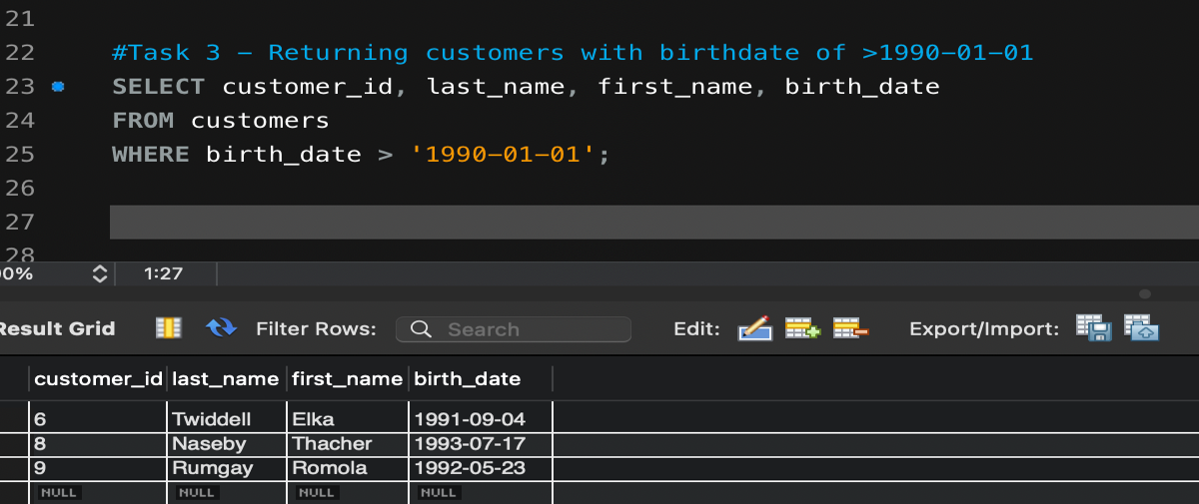

# 

Task 3 - Returning dates of customers who were born after 1st Jan 1990

Task 4 - Finding out product with greatest quantity of stock - resulting in Sweet Pea Sprouts with 98.

Task 5 - Finding name of most expensive product, resulting in "Pork - Bacon, back Peameal" - costing 4.65

Task 6 - Revealing oldest customer on database - Ilene Dawson, born on 30th August 1964

# The EER diagram above visually represents the structure and existing relationships within the database. We can see the entities that exist and the attributes within them. An entity is an object that you would like to describe (customers, products, orders, etc.,), an attribute is a column header and is a piece of information relevant to the entity (names, addresses, date of birth, etc.,). A primary key is one or more columns that uniquely identifies each record in a table, characteristics of a primary key include being unique (each value in the column must be unique across the table), non-null (cannot contain NULL values). Here we see ‘customer_id’ as the primary key for customers and is also a foreign key for the orders entity. A foreign key is a column or set of columns in one table that refers to the primary key in another table – creating a link between the two ensuring referential integrity.

# Task 2 – My SQL Part 2:

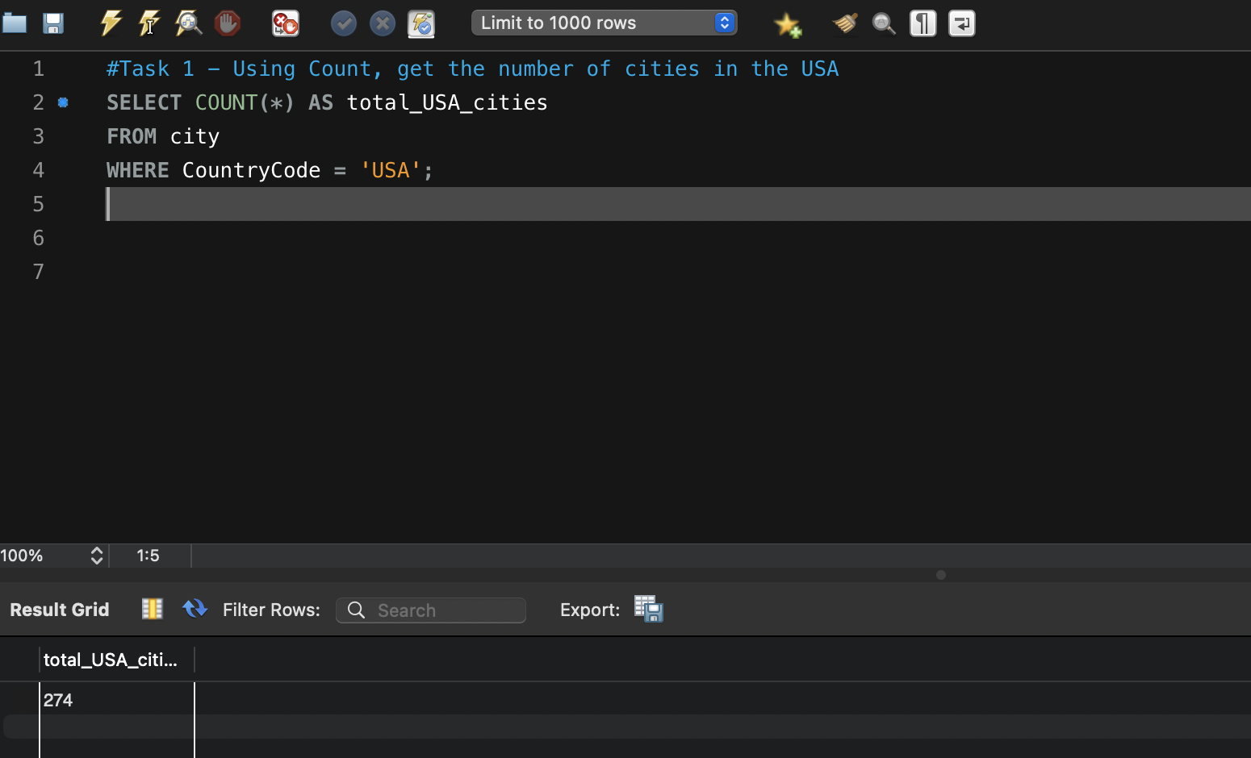Read from PPT for this task first.

Task 1 - Return number of cities by using COUNT function in USA - revealing 274 cities

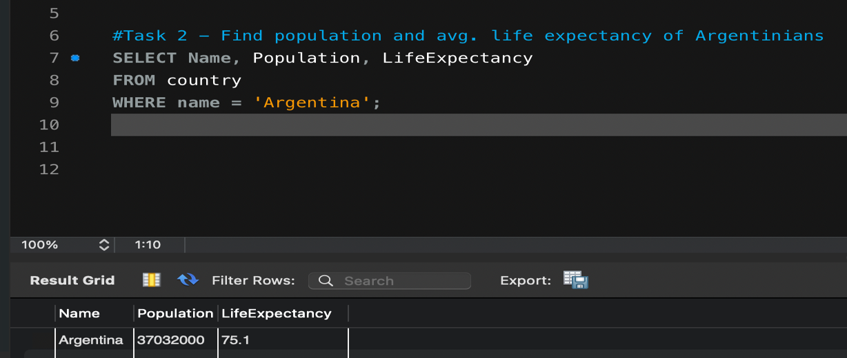

Task 2 - Info about Argentina - population of over 37 million with avg. life expectancy of 75.1

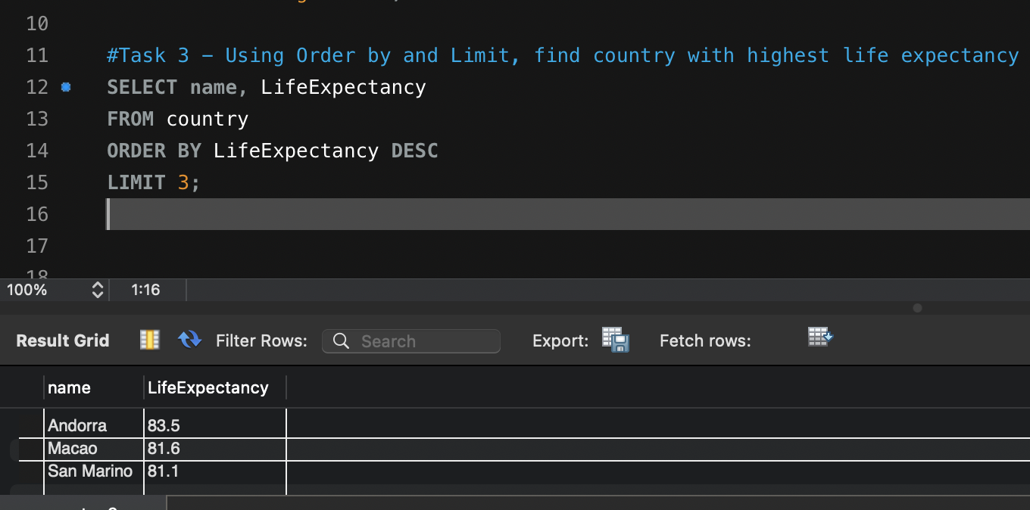

Task 3 - Revealing Andorra to be the country with the highest life expectancy with 83.5

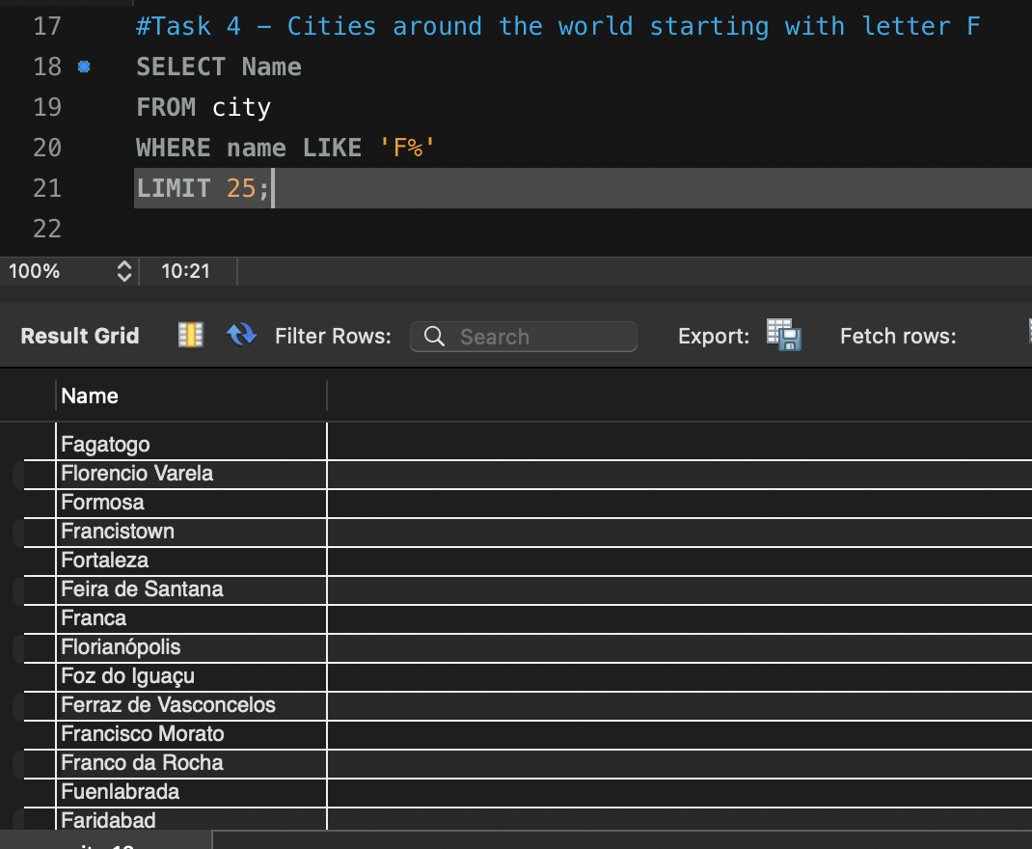

Task 4 - 25 Cities that begin with letter F

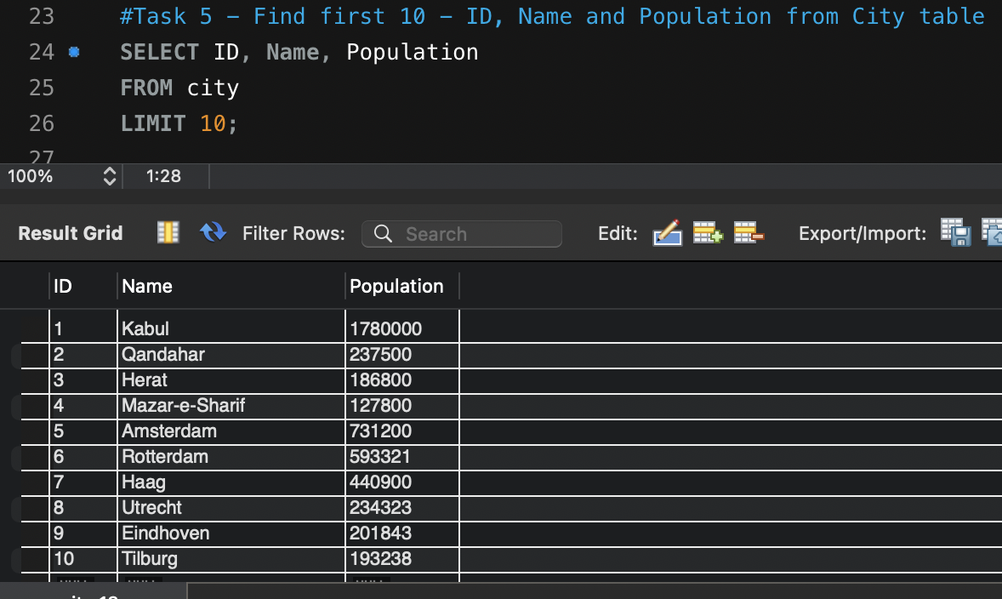

Task 5 - First 10 results from relevant query

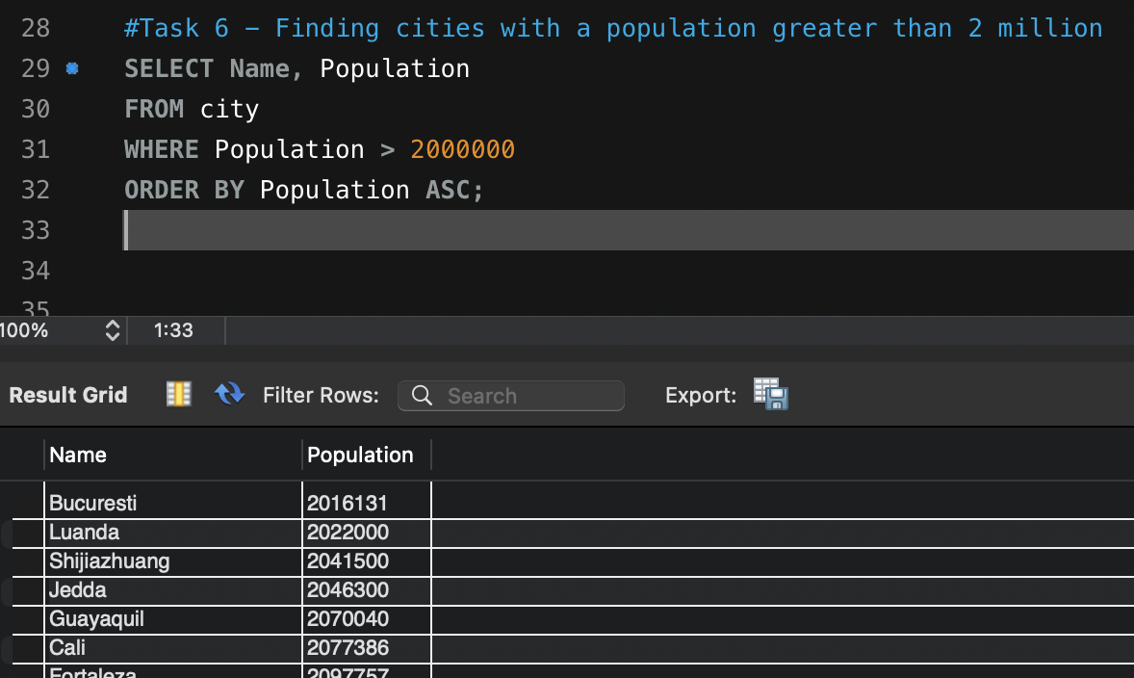

Task 6 -Finding cities with a population greater than 2 million - resulted in 92 cities

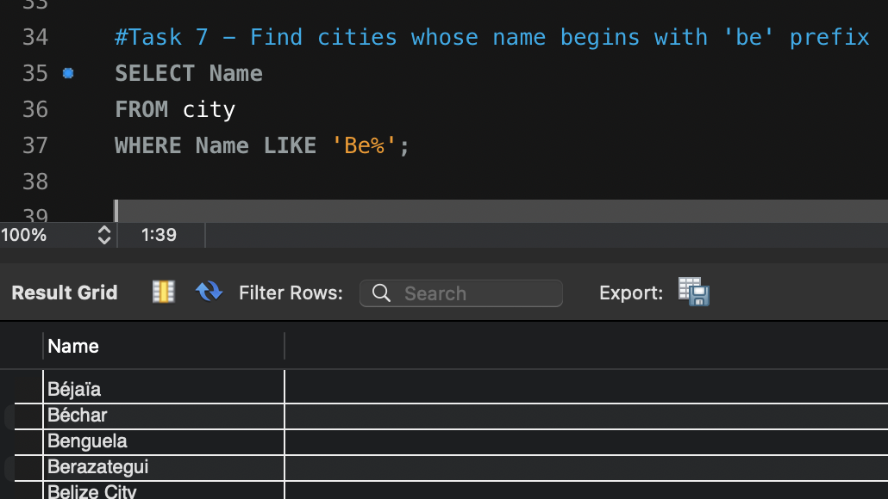

Task 7 – Finding cities that begin with ‘Be” prefix – returned 51 rows so 51 cities begin with ‘Be’ prefix.

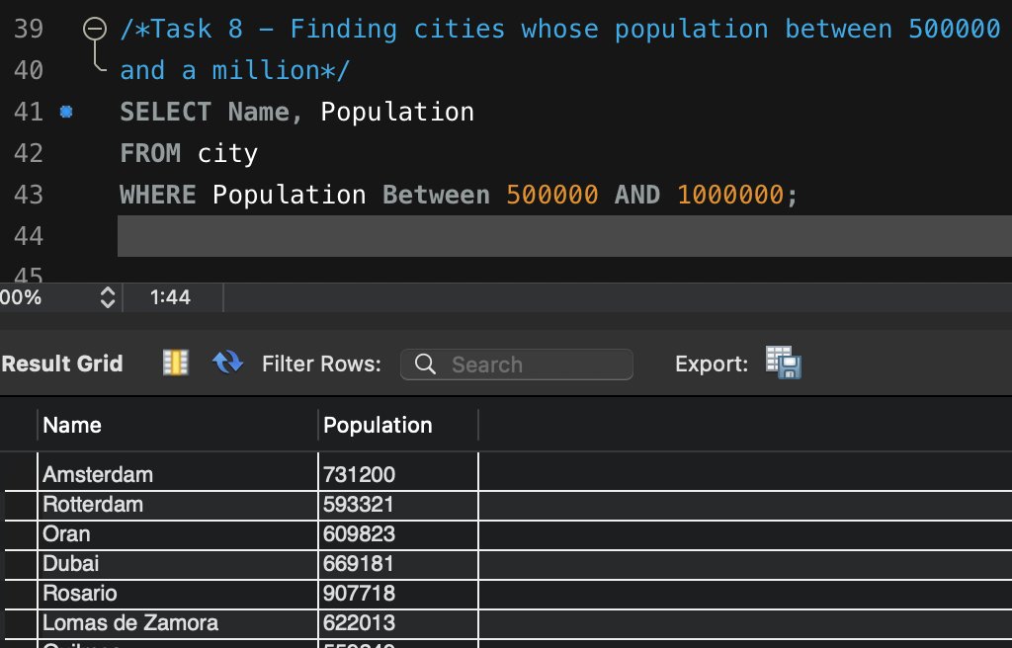

Task 8 - Resulted in 303 cities with a population between half a million and a million

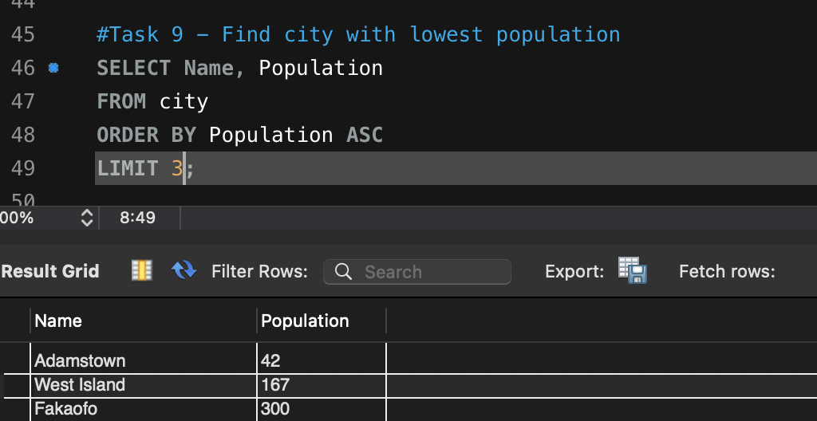

Task 9 - Resulted in Adamstown to be the city with the lowest population of 42.

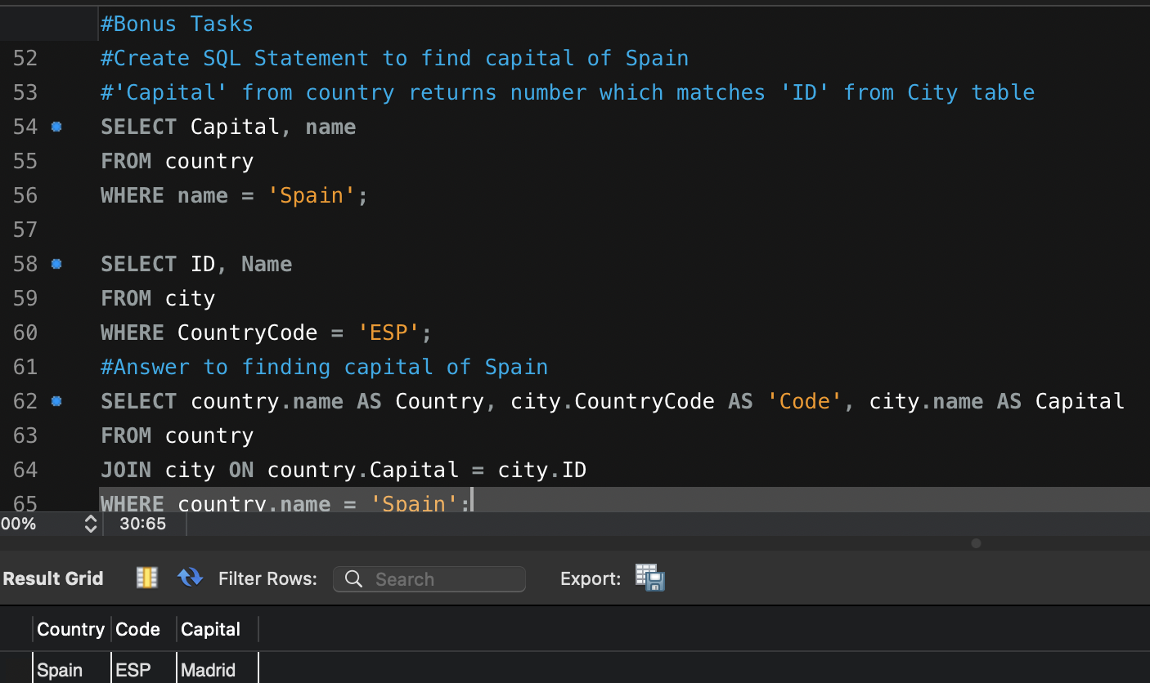Bonus Tasks (Joins)

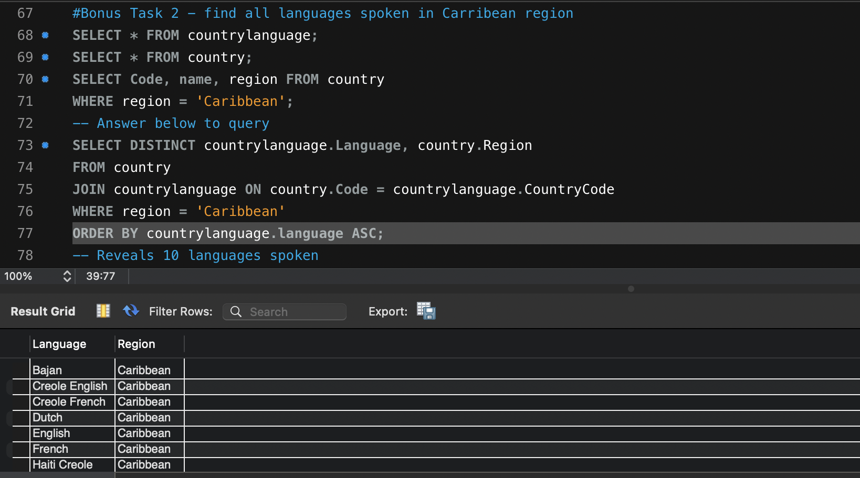This one took a bit of investigative work to find where to correctly join to return the capital city of Spain. Discovered that instances of ‘capital’ from country table matched the instances of ‘ID’ from city table. From here I was able to join the tables and return the capital city of Spain = Madrid.

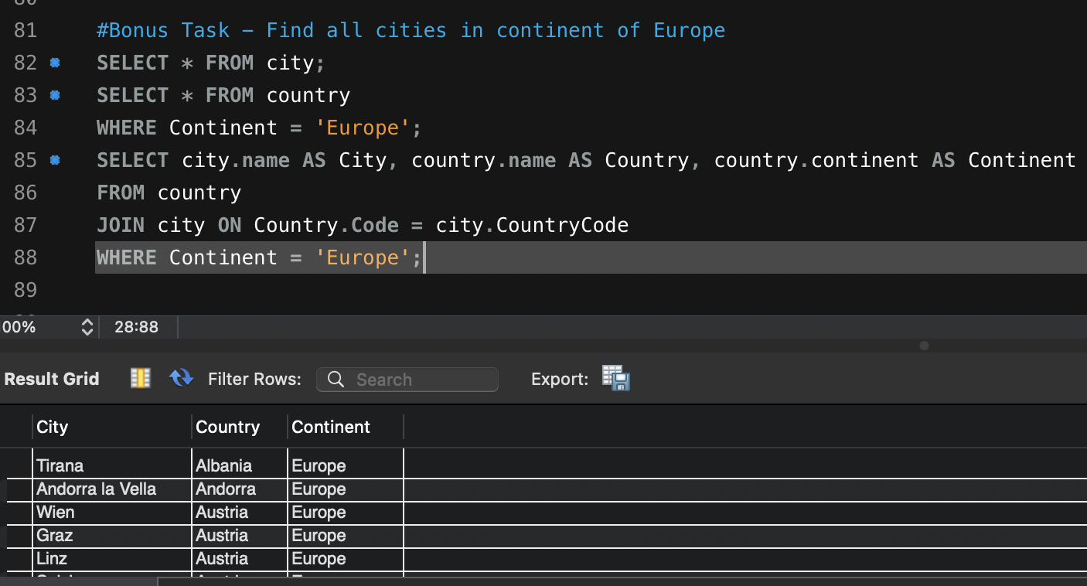Like the previous exercise, needed to see what was common across tables, found ‘Code’ to be common, from here tables could be joined. Revealed all languages spoken throughout the Caribbean (10) with many countries speaking multiple languages.

Revealed 841 cities across Europe.

## A screenshot of a computer Description automatically generatedPrimary Keys

* Country Table = Code
* City Table = ID
* Country Language Table = Country Code and Language

Foreign Keys

* City Table = Country Code
* Country Language Table = Country Code

## Tasks

1. **Count Cities in USA:** *Scenario:* You've been tasked with conducting a demographic analysis of cities in the United States. Your first step is to determine the total number of cities within the country to provide a baseline for further analysis.

Repeated Question from PPT Q’s – 274 Cities in USA – See task 1 in Part 2 for syntax.

1. **Country with Highest Life Expectancy:** *Scenario:* As part of a global health initiative, you've been assigned to identify the country with the highest life expectancy. This information will be crucial for prioritizing healthcare resources and interventions.

Repeated Question from PPT Q’s – Andorra has highest life expectancy of 83.5 – See task 3 in part 2 for syntax.

1. 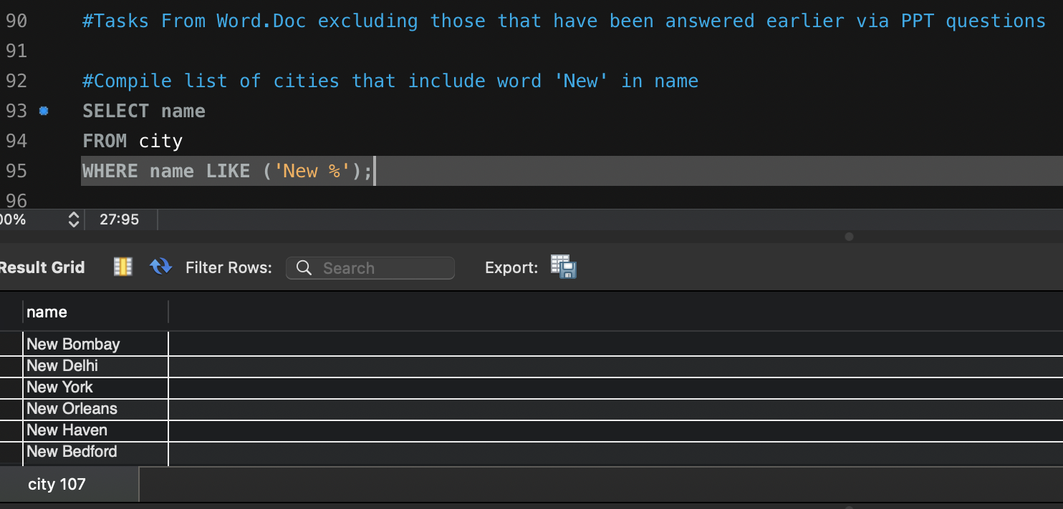**"New Year Promotion: Featuring Cities with 'New :** *Scenario:* In anticipation of the upcoming New Year, your travel agency is gearing up for a special promotion featuring cities with names including the word 'New'. You're tasked with swiftly compiling a list of all cities from around the world. This curated selection will be essential in creating promotional materials and enticing travelers with exciting destinations to kick off the New Year in style.

Revealed 6 Cities starting with 'New' - opted to omit cities that contained New as part of name such as Newcastle by adding space before %

1. 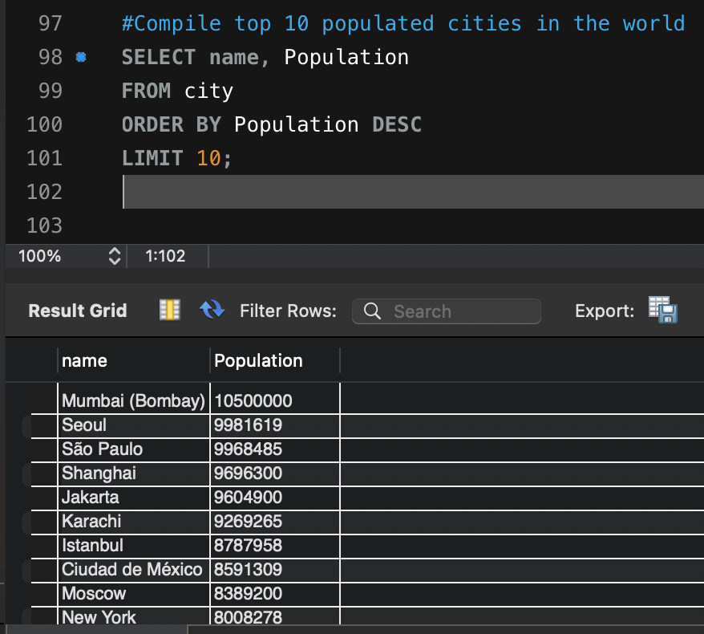**Display Columns with Limit (First 10 Rows):** *Scenario:* You're tasked with providing a brief overview of the most populous cities in the world. To keep the report concise, you're instructed to list only the first 10 cities by population from the database.
2. **Cities with Population Larger than 2,000,000:** *Scenario:* A real estate developer is interested in cities with substantial population sizes for potential investment opportunities. You're tasked with identifying cities from the database with populations exceeding 2 million to focus their research efforts.

Repeated Question from PPT Q’s – 92 cities were returned with a population greater than 2 million – see task 6 in Part 2 for syntax

1. **Cities Beginning with 'Be' Prefix:** *Scenario:* A travel blogger is planning a series of articles featuring cities with unique names. You're tasked with compiling a list of cities from the database that start with the prefix 'Be' to assist in the blogger's content creation process.

Repeated Question from PPT Q’s – Returned 51 rows – see task 7 in Part 2 for syntax

1. **Cities with Population Between 500,000-1,000,000:** *Scenario:* An urban planning committee needs to identify mid-sized cities suitable for infrastructure development projects. You're tasked with identifying cities with populations ranging between 500,000 and 1 million to inform their decision-making process.

Repeated question from PPT Q’s – 303 cities with population between half a million and 1 million – See task 8 in Part 2 for syntax

1. 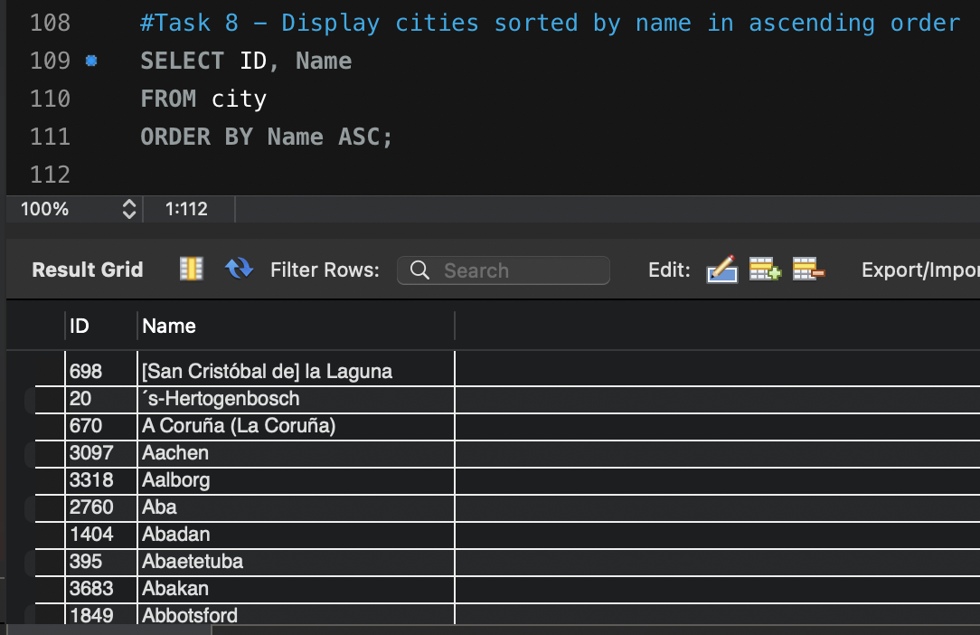**Display Cities Sorted by Name in Ascending Order:** *Scenario:* A geography teacher is preparing a lesson on alphabetical order using city names. You're tasked with providing a sorted list of cities from the database in ascending order by name to support the lesson plan.
2. 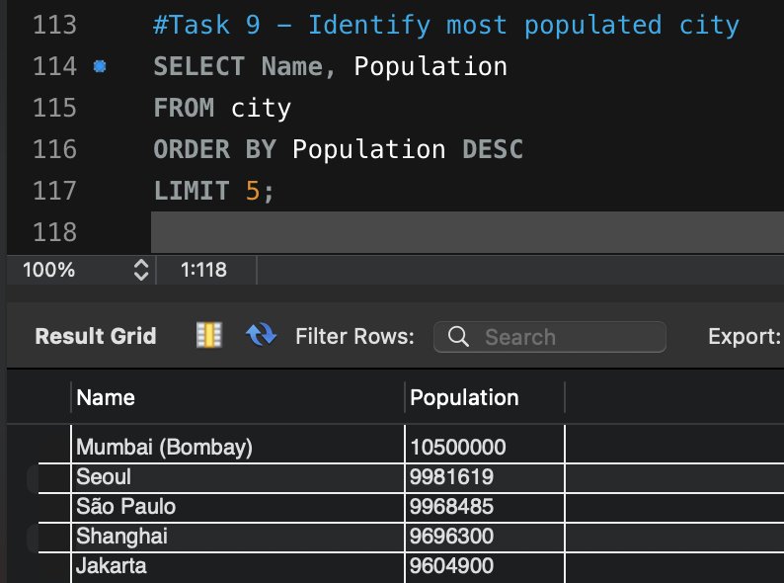**Most Populated City:** *Scenario:* A real estate investment firm is interested in cities with significant population densities for potential development projects. You're tasked with identifying the most populated city from the database to guide their investment decisions and strategic planning.
3. **City Name Frequency Analysis: Supporting Geography Education** *Scenario*: In a geography class, students are learning about the distribution of city names around the world. The teacher, in preparation for a lesson on city name frequencies, wants to provide students with a list of unique city names sorted alphabetically, along with their respective counts of occurrences in the 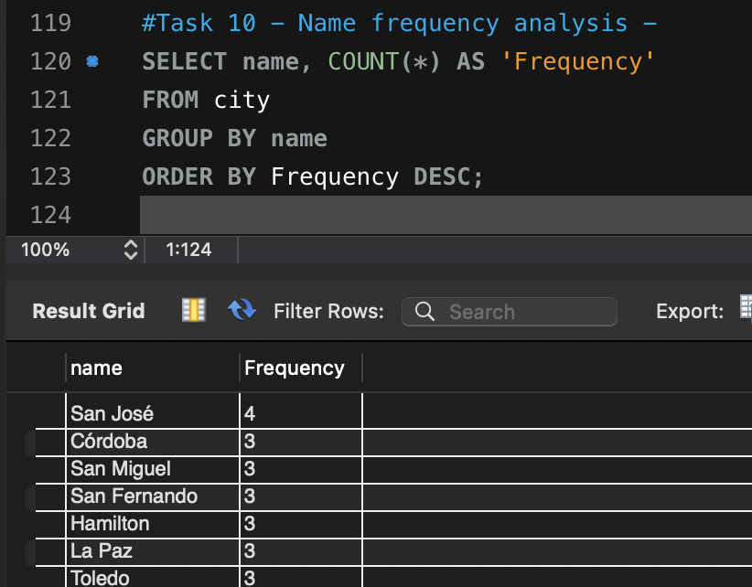database. You're tasked with this sorted list to support the geography teacher's l

Group BY function here is used to group identical names together with COUNT then counting occurrences of each name in relevant table, shows San José being the most frequently used city name.

1. **City with the Lowest Population:** *Scenario:* A census bureau is conducting an analysis of urban population distribution. You're tasked with identifying the city with the lowest population from the database to provide a comprehensive overview of demographic trends.

Repeated question from PPT Q’s – Adamstown is the city with the lowest population (42) – See task 9 in Part 2 for syntax.

1. 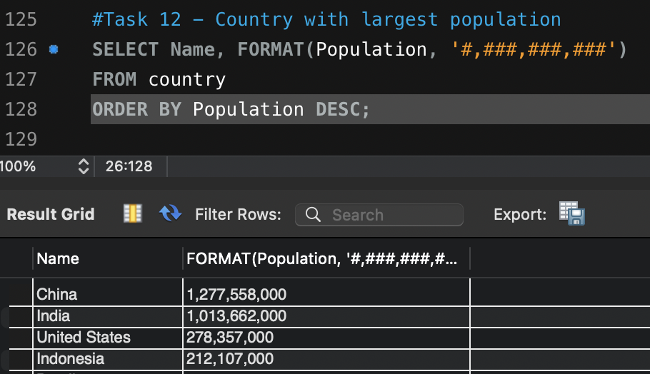**Country with Largest Population:** *Scenario:* A global economic research institute requires data on countries with the largest populations for a comprehensive analysis. You're tasked with identifying the country with the highest population from the database to provide valuable insights into demographic trends.

Used ORDER BY function to sort population from highest to lowest whilst also editing format of how the numbers were presented to enable greater reader friendliness. Can easily see China as the most populated country with over 1.2billion citizens.

1. **Capital of Spain:** *Scenario:* A travel agency is organizing tours across Europe and needs accurate information on capital cities. You're tasked with identifying the capital of Spain from the database to ensure itinerary accuracy and provide travelers with essential destination information.

Repeated question from bonus joins task – Madrid is capital of Spain – See first task on page 9 of this doc for syntax

1. **Country with Highest Life Expectancy:** *Scenario:* A healthcare foundation is conducting research on global health indicators. You're tasked with identifying the country with the highest life expectancy from the database to inform their efforts in improving healthcare systems and policies.

Repeated question from PPT Q’s and Task sheet – Andorra has highest life expectancy of 83.5 – See task 3 in Part 2 for syntax

1. **Cities in Europe:** *Scenario:* A European cultural exchange program is seeking to connect students with cities across the continent. You're tasked with compiling a list of cities located in Europe from the database to facilitate program planning and student engagement.

Repeated question from joins task – 841 cities across Europe – See task 3 on page 9 of this doc for syntax

1. 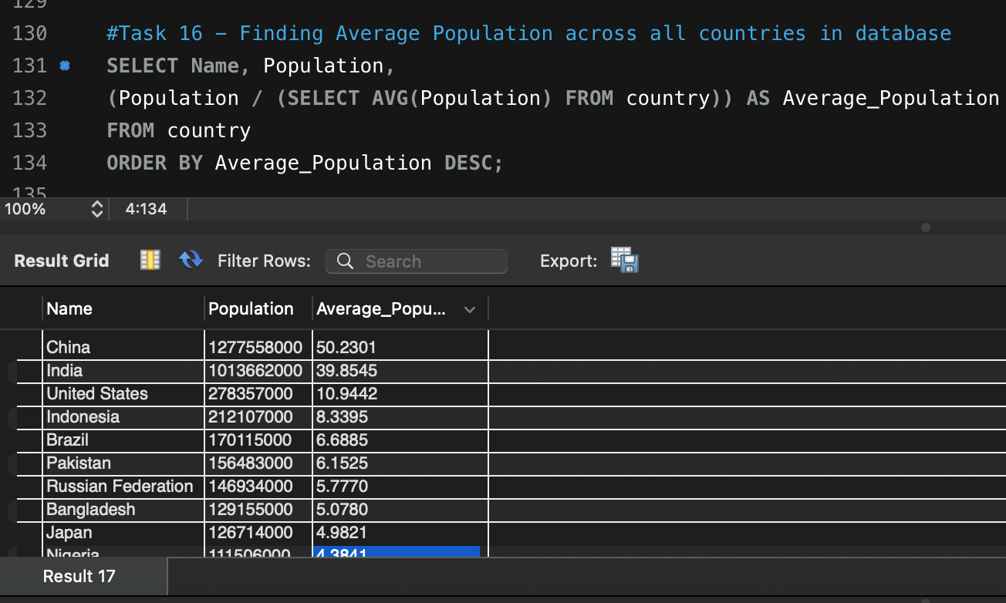**Average Population by Country:** *Scenario:* A demographic research team is conducting a comparative analysis of population distributions across countries. You're tasked with calculating the average population for each country from the database to provide valuable insights into global population trends.

From this query we can see that China has a population which is 50 times greater than the average population across all countries in the dataset.

1. 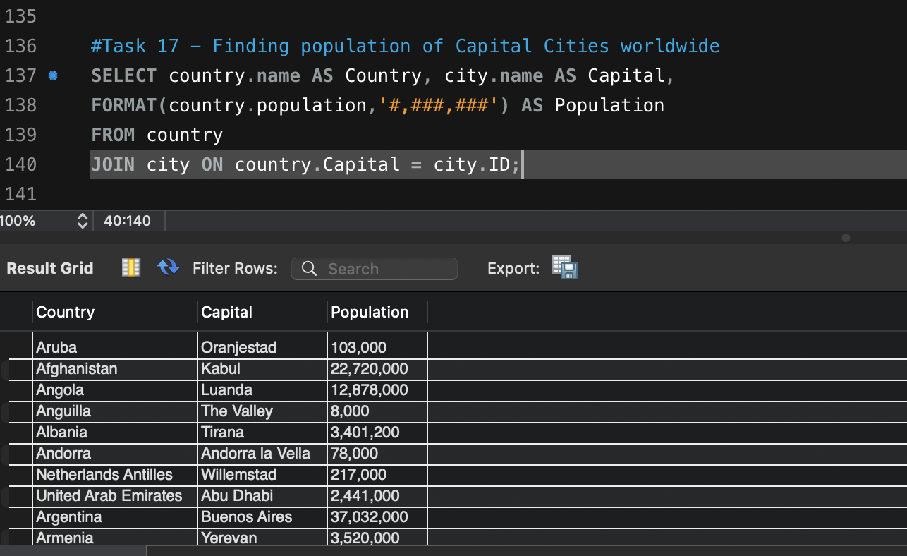**Capital Cities Population Comparison:** *Scenario:* A statistical analysis firm is examining population distributions between capital cities worldwide. You're tasked with comparing the populations of capital cities from different countries to identify trends and patterns in urban demographics.

Required to join tables here to find population of capital cities.

1. 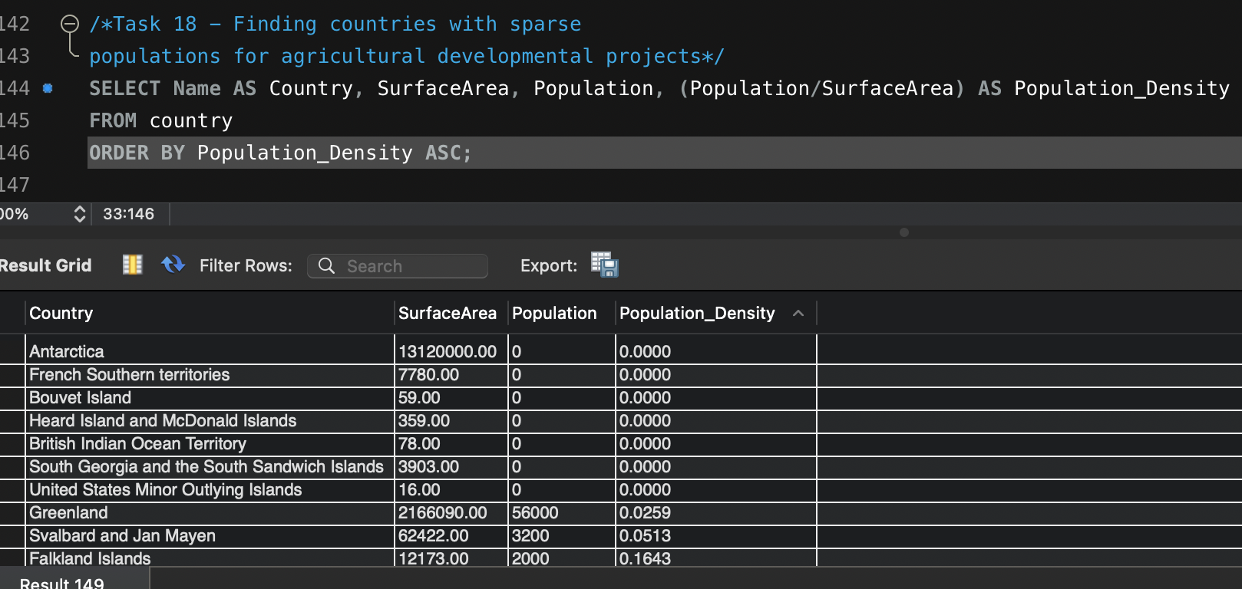**Countries with Low Population Density:** *Scenario:* An agricultural research institute is studying countries with low population densities for potential agricultural development projects. You're tasked with identifying countries with sparse populations from the database to support the institute's research efforts.

Thought finding out the population density by dividing population by surface area would provide a list of countries that had land greater than its inhabitants. This would mean a great chance to study the land for potential agricultural development projects.

BONUS TASKS: Challenge yourself: These are optional tasks. Feel free to skip.

1. 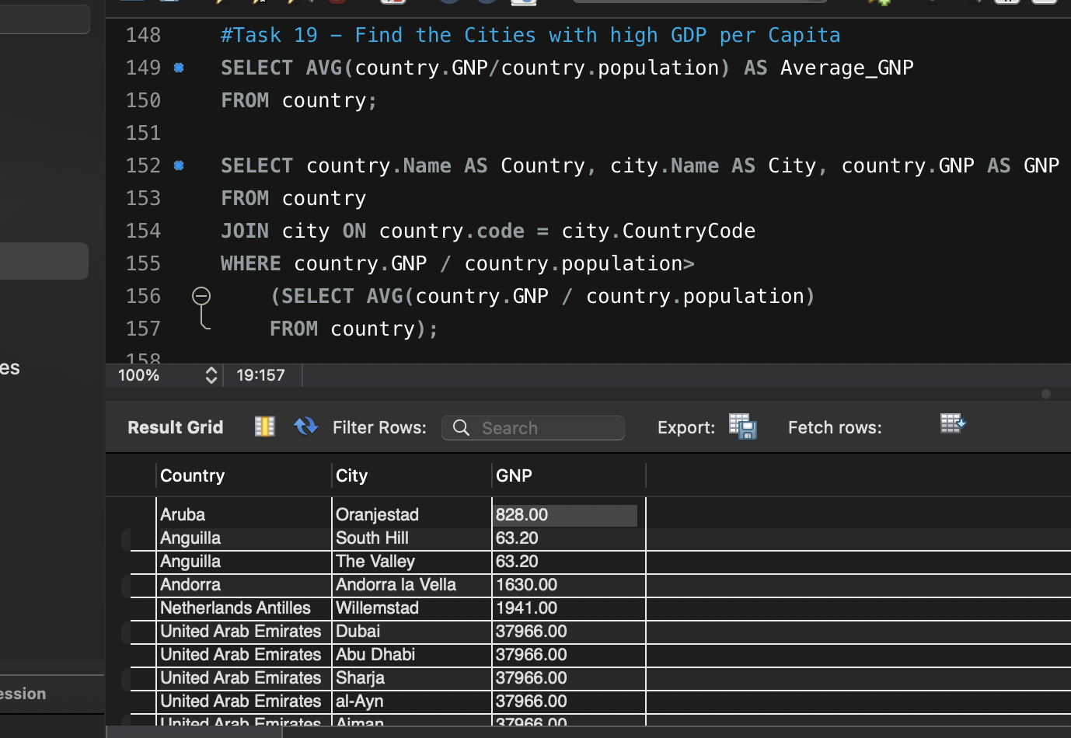**Cities with High GDP per Capita:** *Scenario:* An economic consulting firm is analyzing cities with high GDP per capita for investment opportunities. You're tasked with identifying cities with above-average GDP per capita from the database to assist the firm in identifying potential investment destinations.

Not sure if this is correct as there is not a 'GDP' attribute within the dataset. Used the GNP attribute instead and joined city and country table. Found all cities within a country but couldn’t average per city, had same GNP as it's their GrossNationalProduct. Was still able to only return those that were above the average GNP across all countries.

1. 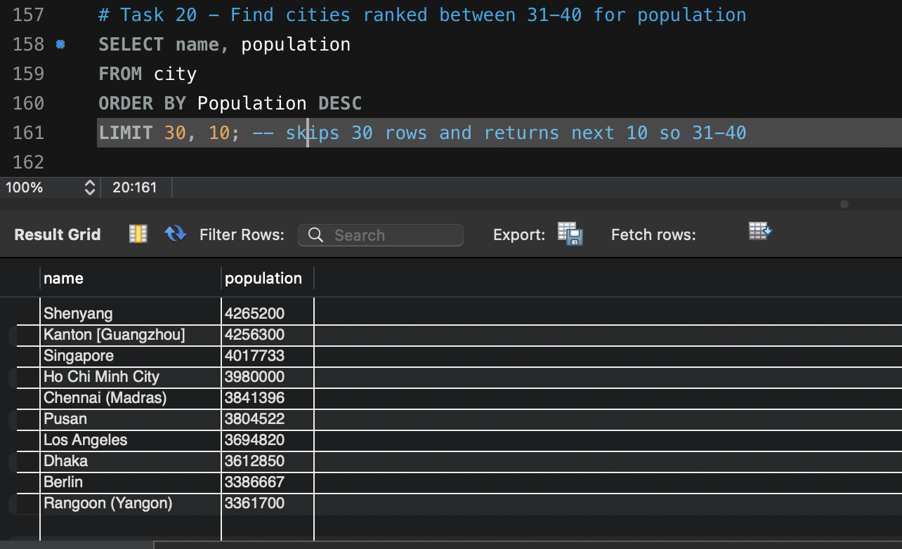**Display Columns with Limit (Rows 31-40):** *Scenario:* A market research firm requires detailed information on cities beyond the top rankings for a comprehensive analysis. You're tasked with providing data on cities ranked between 31st and 40th by population to ensure a thorough understanding of urban demographics.

Using LIMIT function can return specified number of rows, within the syntax ‘LIMIT 30, 10” indicates the want to skip the first 30 rows and only collect the 10 after hence returning rows 31 – 40.

# Task 3 – Interview Part 1:

**Q1 – What is a Query?**

* A query is a formatted way to request or manipulate data from a database. Essentially the language used to tell a database what to do, be that retrieve information or update information.

**Q2 – What is the SELECT statement?**

* SELECT is used to return data from a specified column from a specified table, tells the programming language what is desired to be obtained

**Q3 – What is the WHERE clause?**

* WHERE allows specific conditions to be met, can use operators such as =, <, >, and. Or, NOT, between, LIKE etc. Allows for filtering of data, conditions must be met for data to be returned.

**Q4 – What is the Primary Key?**

* A primary key in a relational database is a column or set of columns that uniquely identifies each record in a table. It ensures each record is distinct and can be easily accessed whilst relatable to other data in the database

**Q5 – What is a Database?**

* A database is an organised collection of data usually stored in an electronic format and allows inputting, organising and retrieving data quickly. Essentially a central system where data can be stored and queried.

# Task 4 – Interview questions Part 2:

**Q1 – List different types of relationships in SQL and provide examples.**

Relationships refer to how different tables relate to one another in the database. Types inc. one-to-one, one-to-many or many-to-one and many-to-many.

* One-to-one
  + Where a single record in a table is related to a single record in another table
    - A person and their driving license number (each person has one unique driving license number)
* One-to-many or many-to-one
  + A single record in one table relates to multiple records in others
    - Library – one author can write multiple books, but each book has one unique author
* Many-to-many
  + Where multiple records in a table relate to multiple records in another table
    - In school, a student can join multiple clubs, and each club can have multiple students.

**Q2 – What is Normalisation?**

* Refers to schema design process that reduces data duplication and enforces data integrity, certain rules must be followed
  + Separate each entity into its own table
  + Separate each unique attribute into its own column
  + Define a primary key for each entity instance or row that uniquely identifies that row
  + Define foreign key columns to link related tables

**Q3 – Modify query to show population of Germany**

* SELECT population FROM world
* WHERE name = ‘France’

SELECT population

FROM world

WHERE name = ’Germany’;

**Q4 – Query which gives name of countries beginning with ‘U’**

SELECT name

FROM world

WHERE name

LIKE ‘U%”

**Q5 – Answer is b – ‘name’ should be name**

**Q6 – Code that returns countries ending with letter a or l**

* SELECT name FROM world WHERE name LIKE ‘%a’ or name LIKE ‘%l’

**Q7 – Code that produces table desired**

* SELECT name, population FROM world WHERE population BETWEEN 1000000 AND 1250000